**Name:-** Gaurang A Raorane **Div:-** D15A

**Roll No:-** 49 **Batch:-** C

**LAB 4**

**Aim :- Advanced git commands**

**branching**

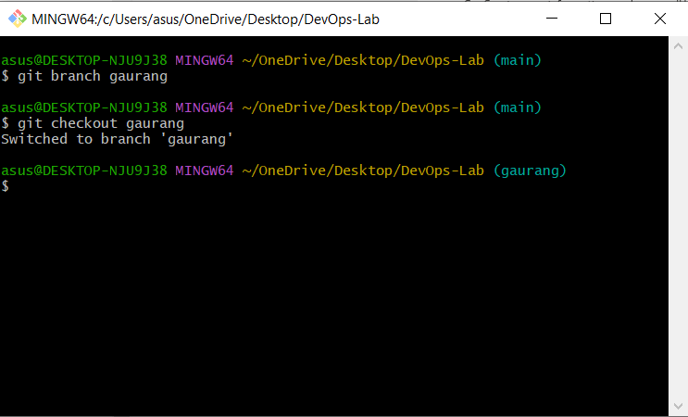

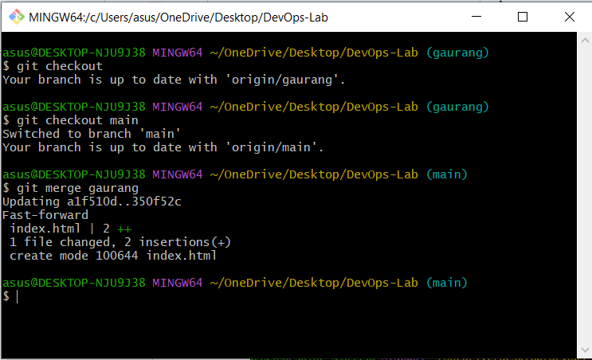

**Git log**

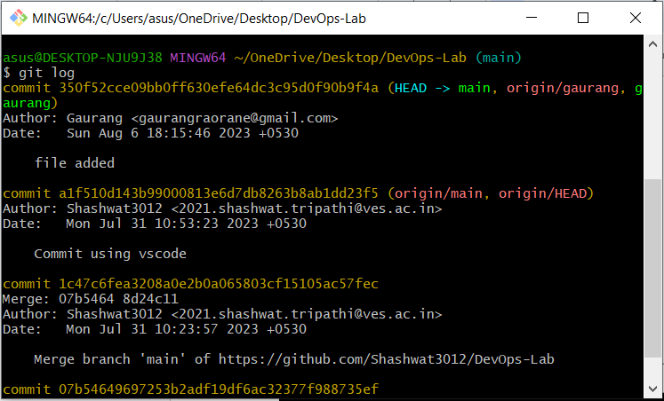

**Git diff**

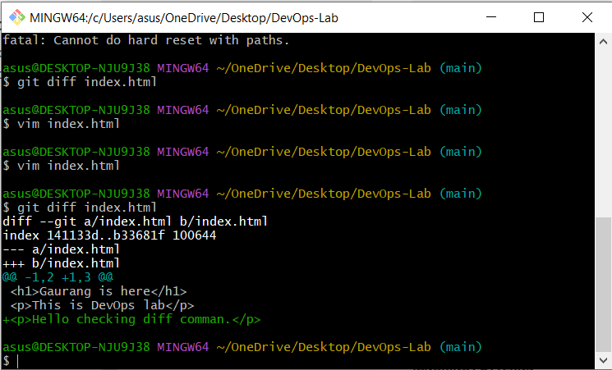

**Git stash**

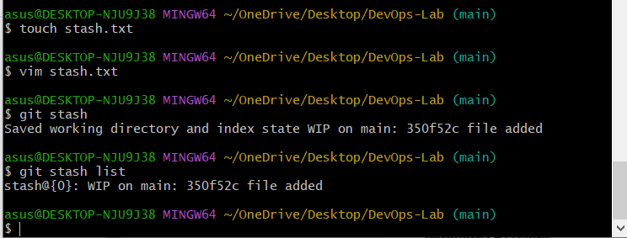

**Git rebase**

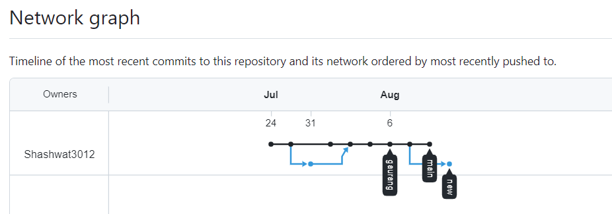

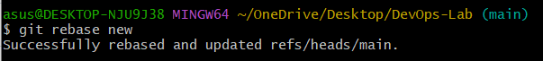

**Git revert**

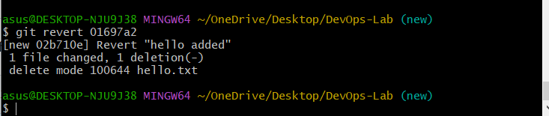

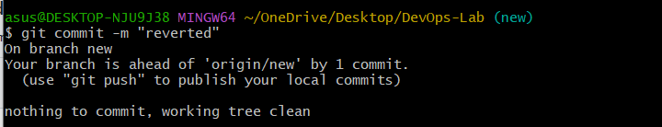

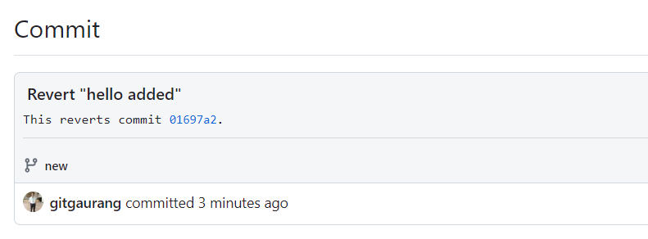

**Conclusion:-**

Performed advanced git commands.